Minutes

Face 2 Face + Virtual

TAC 137

301 MIC Corrosion in Stainless Steels

Date: 01 March 2022
Time: 11:00 am to 11:50 am

Attendees: see Attachment A

PDH record/information:
_1_ professional development hours (PDH) are made available to the above MTI members/attendees

Meeting notes:
Introductions -

Presentation - See Attachment B

Three companies have agreed to conduct the testing

Plan is to order one rack and modify as needed for this testing
- Need to identify who can modify the rack

Alloys to test:
- 316 - S31600
- 2101 - S32101
- 2205 - S31803
- 2507 - S32750
- 2707 - S32707

AL6XN testing is proposed 304 had been suggested to be included in Dec 2021 meeting -

Change all references to UNS numbers rather than those listed above for final SPS/RFP

Look at previous test protocol around 2005 ICA PDC had embarked on similar project - Tony Scribner will locate and submit for background. Team was aware of this and have reviewed -

Samples will include a weld - additional requirements for the weld will be needed for the SPS - heat tint of 2 max. Ti no heat tint.

Currently 11 metallurgies are being considered - the first 5 are locked in and the remaining are to be determined by member survey.

Visual inspection and weight loss will be used to determine extent of MIC

Concern around need for multi step testing - this one test may not provide the desired results.

Notes from Karen

- MIC meeting
- 3 companies agreed to do the testing
  - Nova Chem
  - Eastman - 2x
  - Advansix
- Metallurgies 9
  - Welded coupons
  - Definition will be as a survey
  - First 5 alloys are locked - decision to be taken on the other 4
  - Comments add to the list
    - Use UNS numbers
    - Input Rolled Alloys - 6XN
    - Input Plymouth - Seacure (Dan can supply samples) UNS S44660
    - F255 - has copper
    - One of the CuNi
    - Titanium
    - 254 SMO
  - Thin enough probably use TIG
    - Acceptance of heat tint - average is a 2
- Result
  - Weight loss is ok

Actions
- Send survey by the end of march - who to send?
- Call a meeting with Curtis to discuss adapting the rack
- Dale to purchase the rack and ship it to Eastman - NO see below:
  - need proposal / quote for purchase - these items are typically procured by contractor performing the work / testing
    - Dale will inquire local plastic fabrication shop (SG&P in Freeport TX) and Nalco for proposals for team review - need a diagram of the test rack for proposal to local plastic fabricator
  - Need information on the intended flow capacity of the rack - see Nalco literature:
    - 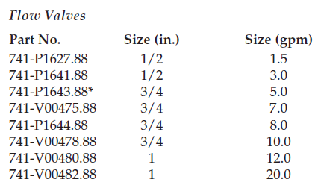

Questions:
- Since Dale is new to this project he has questions:
  - Is the current team aware of the work on similar testing done around 2010/2012 when Tony Scribner was MTI AD?
  - Is there any reason the test rack from this project cannot be used/duplicated?
  - The testing from this project did not result in any MIC on the coupons - see attached documents that Tony was able to supply to Dale during TAC - the rack was shipped to Kevin Ganschaw - I have emailed Kevin to get additional background on results and whereabouts of the test rack shipped to him - see attachment C and D for additional files related to this testing.
  - Below is picture of the rack and shipping receipt
